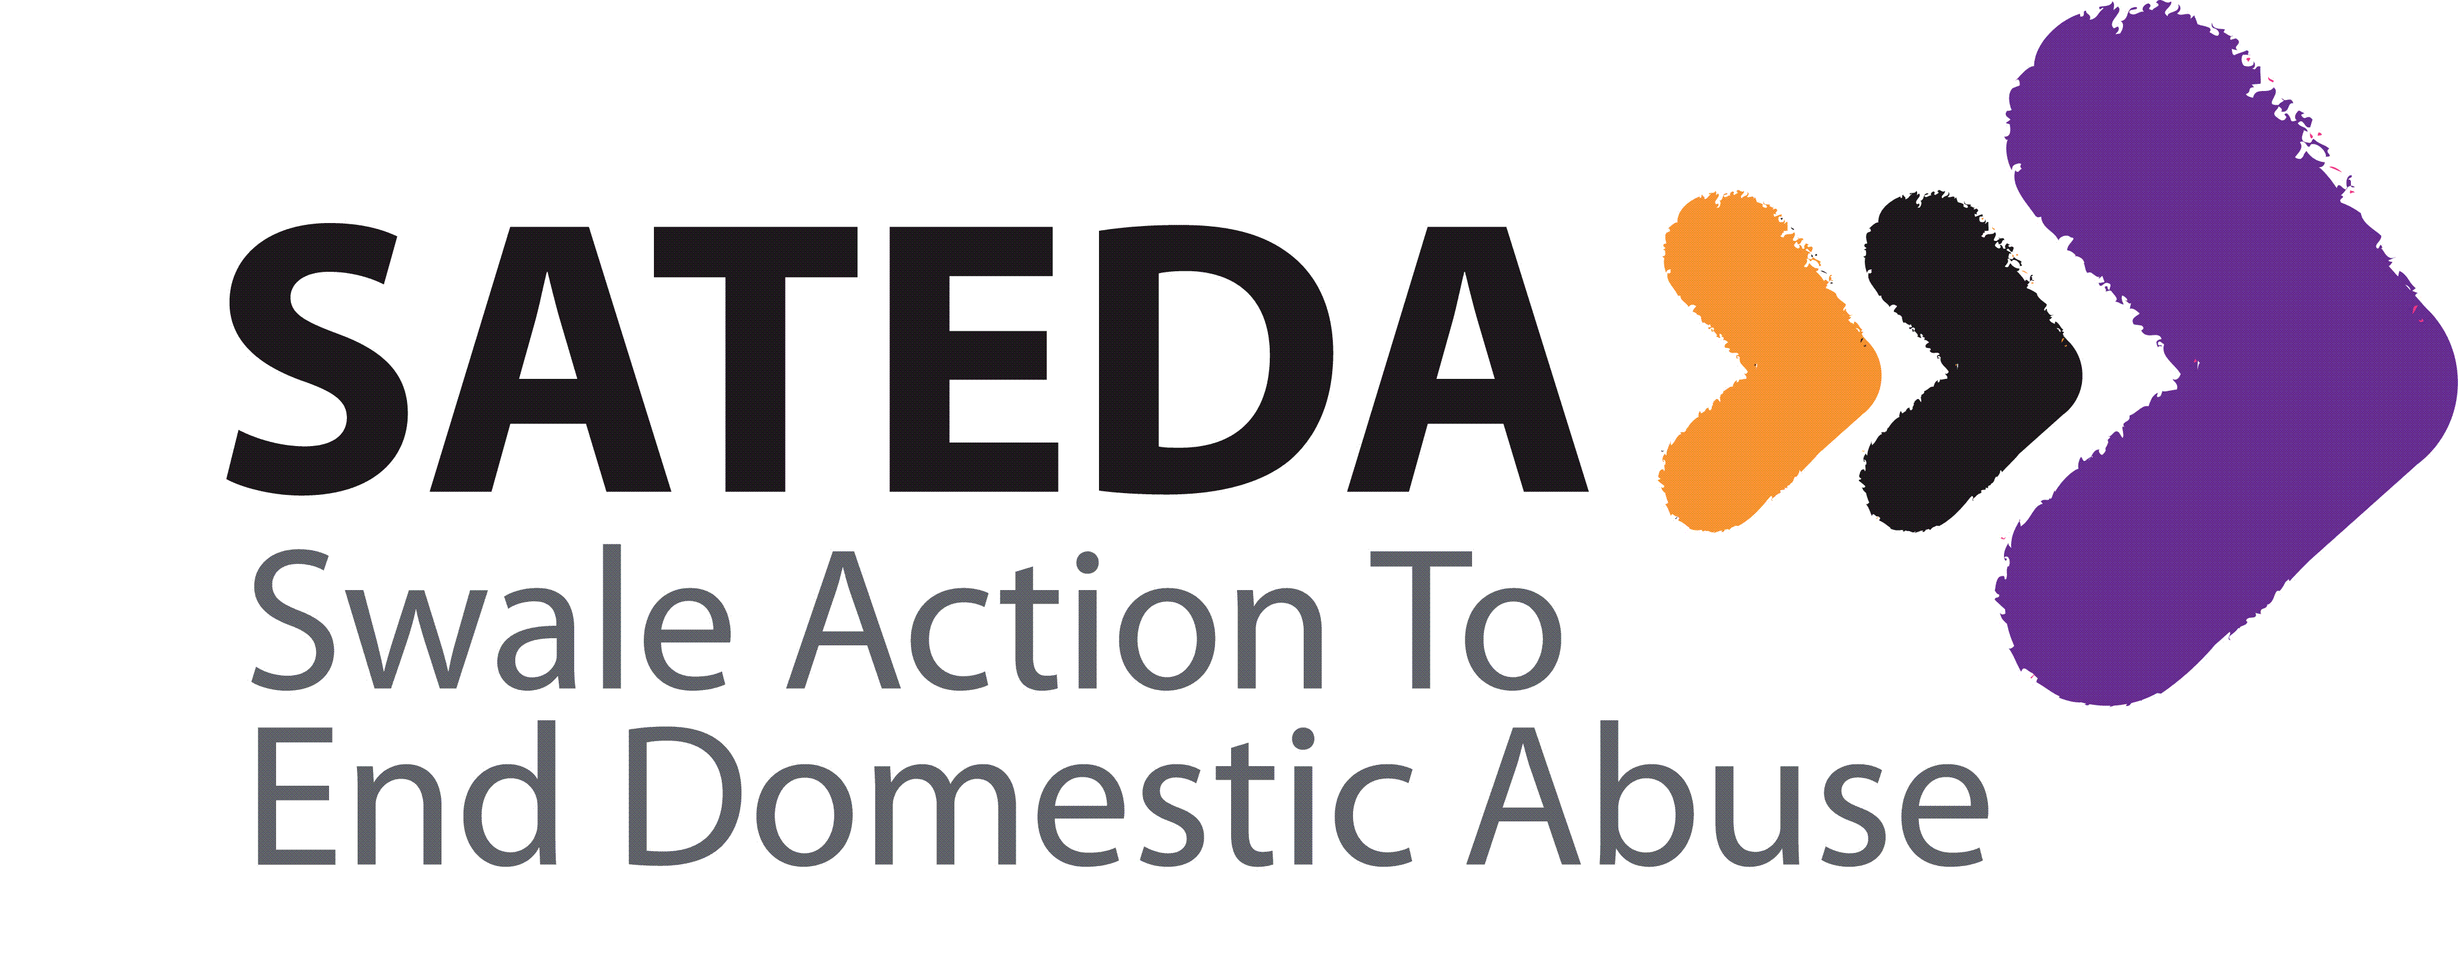

Job Title Freedom Programme Facilitator
Employer SATEDA (Swale Action to End Domestic Abuse)
Reports to: Freedom Programme Coordinator
Location: Swale
Salary: £15,530 pro rata
Hours: 12 hours a week - contracted or sessional working depending on the requirements of the candidate
Deadline to submit applications: 18 Nov 2016
Job Description
- To deliver freedom programme sessions at various locations across Swale
- To assist Freedom Programme Coordinator to organise programme delivery
- To liaise with partner agencies in line with freedom programme participant needs
- To keep an accurate and clear record of sessions – utilising case management system
- To ensure monitoring and evaluation processes are adhered to during and in between programme delivery
- To contact prospective freedom programme participants to assess suitability for the programme
- To keep in contact with freedom programme participants between sessions to monitor safety and wellbeing
- To risk assess venues and ensure health and safety is adhered to each week

Person Specification
Essential

- Freedom programme facilitator trained
- Ability to adapt to a variety of needs
- Able to use Initiative
- Flexibility
- Ability to work in a self-led environment
- Experience of working with volunteers
- Driving licence and use of car

Skills
- Excellent communication skills
- Ability to maintain professional boundaries
- Excellent listening skills
- Good computer skills
- Ability to work to tight deadlines and in a busy environment
- Ability to work reactively to the needs of the project
- Ability and willingness to work in partnership with statutory and voluntary partners

Personal qualities
• Pro-active
• Reactive
• Compassionate
• Commitment to undertake regular training
• Ability to work as part of a team
Footnotes
The post holder may be required to undertake any other duties that fall within the nature of the role and responsibilities of the post as detailed above.
The post holder will need to undertake an enhanced DBS check.

