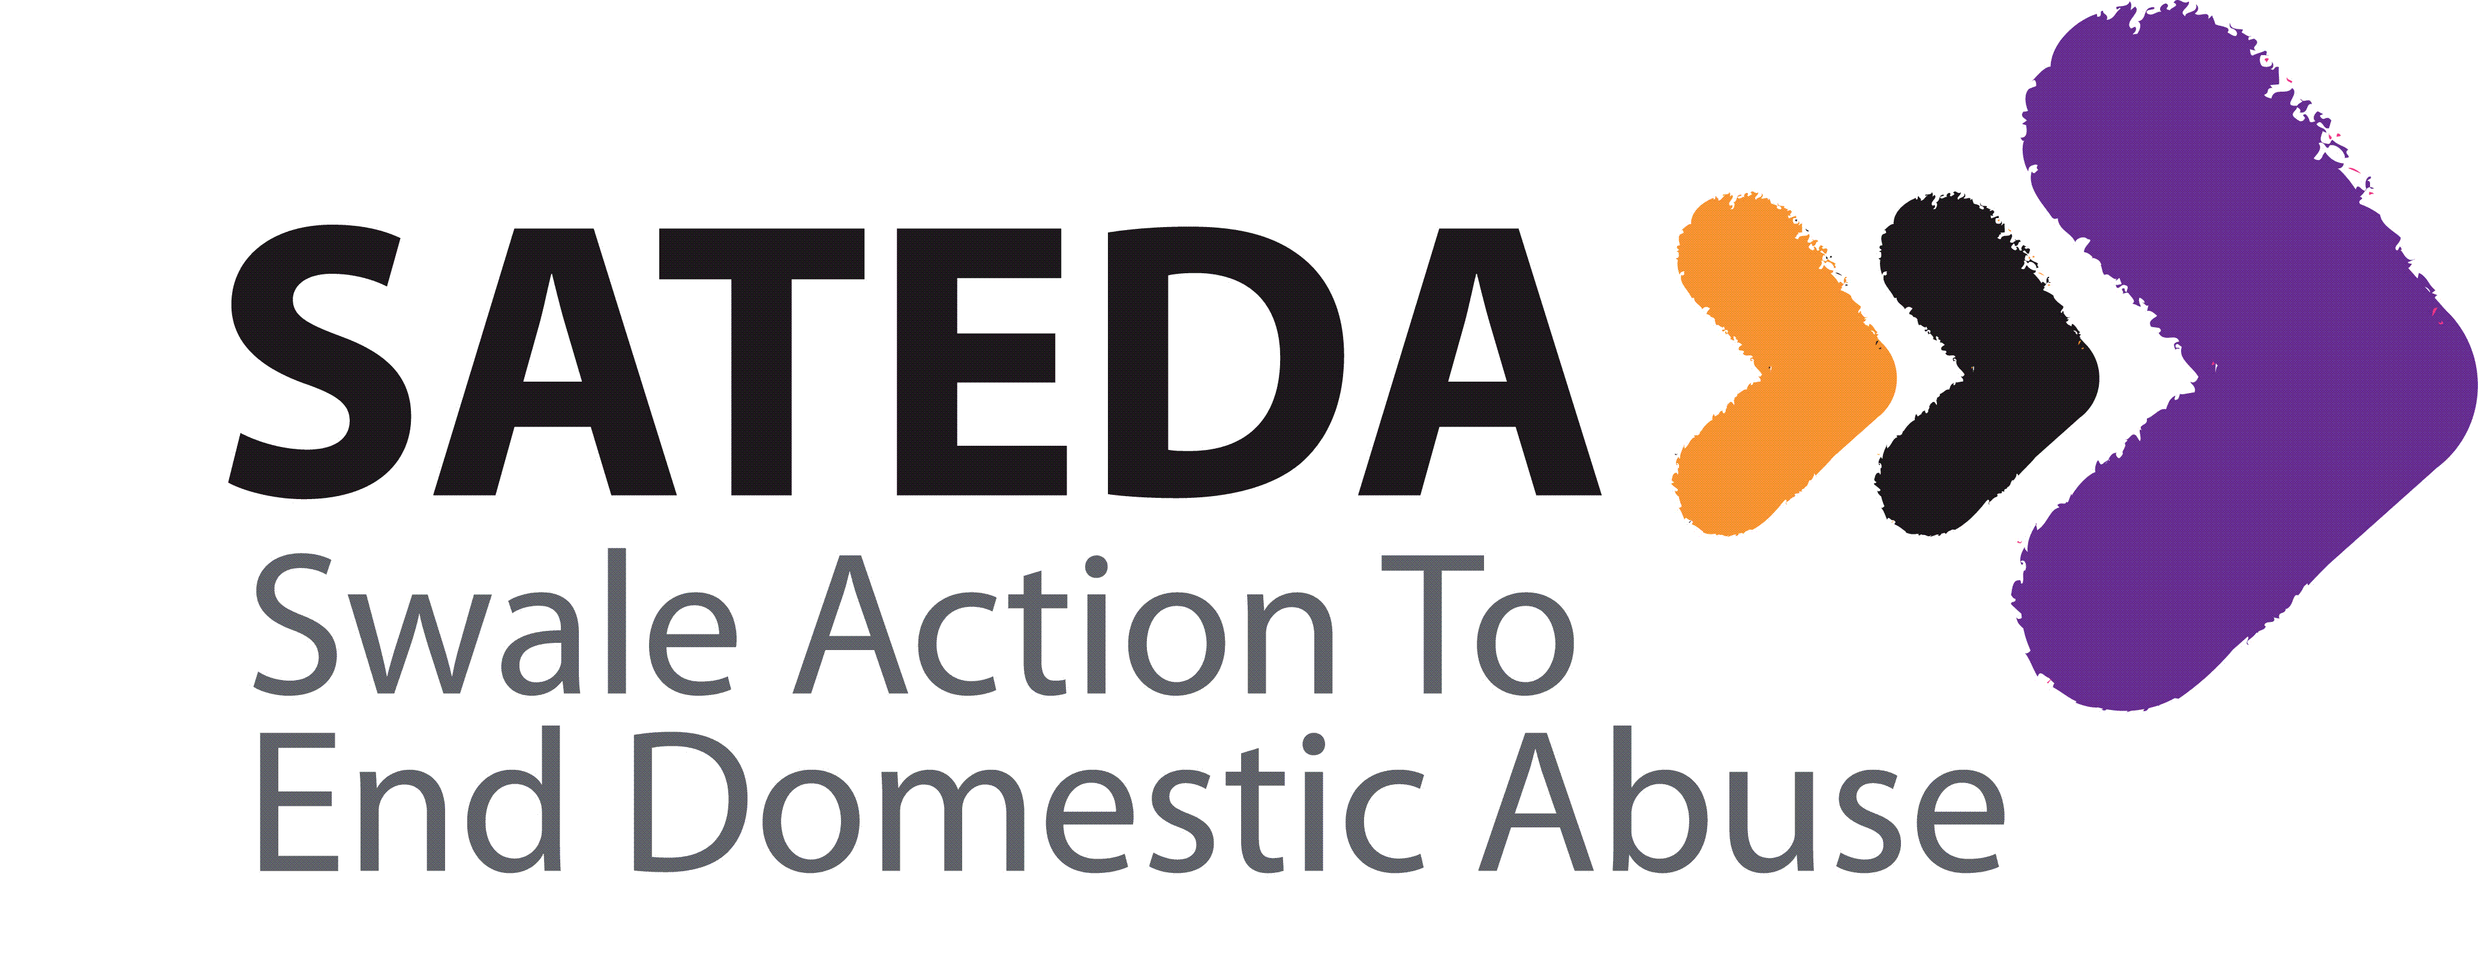

Job Title Sessional Crèche Workers
Employer SATEDA (Swale Action to End Domestic Abuse)
Reports to: Freedom Programme Coordinator
Location: Swale
Salary: £8.50 per hour plus out of pocket expenses
Hours: sessional
Deadline to submit applications: 18 Nov 2016
Job Description
SATEDA is looking to appoint a team of sessional crèche workers to support the team in providing crèche for parents and carers who attend our courses. Our crèche services are delivered in a range of community venues across Swale area.
We are looking for enthusiastic and professional crèche workers who are experienced in providing quality crèche for children and babies. The ability to deliver crèche from a range of different venues across the District of Swale is required, therefore a driving licence and the use of a car is important to these roles.

Main responsibilities:

- Provide physical care of babies and children under the age of five

- Create a safe & stimulating play environment for children under the age of five
- Set out equipment, ensure tidiness & clear up at the end of the session.

- Complete the session Planning Sheet and provide varied and creative activities appropriate to each child.
- Support in completing room Health & Safety check list each session

- Liaise with other staff within the crèche
- Support parents/carers in completing the Crèche Registration form and liaise with parents/carers about their child’s needs.

- Work as a team in general decision making.
- Implement the child protection and health and safety policies.
- Abide by other relevant policies: i.e. equal opportunities, confidentiality.
- Make yourself familiar with the Venue emergency procedures i.e. fire, where the first aid box & Accident book are located.

Person Specification
QUALIFICATIONS
- NVQ Level 2 or above
- Equivalent qualification in Early Years or play work
- First Aid

EXPERIENCE
- Working with U5's
- Ability to provide appropriate care
- Ability to provide appropriate activities
- Experience of working from a variety of settings

COMMUNICATION
- Communicates effectively
- Clear & concise
- Listens
- Understands confidentiality

TEAMWORK & INTERDEPENDENCE
- Develops productive relationships
- Recognises other's contributions
- Shares ideas
- Makes positive contribution

PLANNING & ORGANISING
- Plans varied and creative activities appropriate to age groups
- Able to prioritise and re-prioritise
- Anticipates issues & able to plan ahead
- Works within H&S guidelines

INITIATIVE/ DECISION MAKING
- Displays positive outlook and suggests solutions
- Eager to learn & put training into action
- Keeps up to date & well informed
- Makes decisions firmly and fairly based on sound judgements
- Continually strives to improve and support change
Footnotes
The post holder may be required to undertake any other duties that fall within the nature of the role and responsibilities of the post as detailed above. The post holder will need to undertake an enhanced DBS check.

