

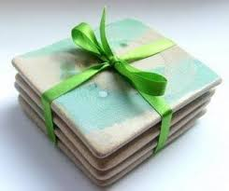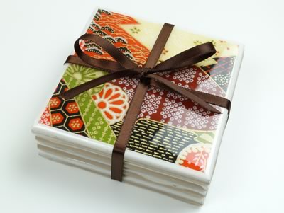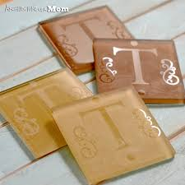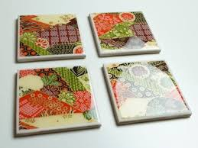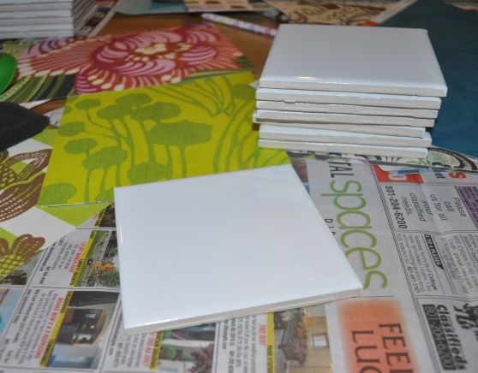

**Bring a friend and pay £9.50 for two.**

**BOOK NOW**

**owecic@gmail.com or call Angela on 07956 254 119**

**Or why not make some for family/friends for a fun and original gift idea.**

Cost £5.00 per person & includes 2 ceramic tiles each 4" (10 cm) square, materials, and refreshments.

Extra tiles cost 59p.

**It’s Christmas soon so, wow your guest and personalised it.**

**Make Your Christmas Table Coasters with Opportunities with Experience O-W-E C.I.C**

**Where: At our NEW workshop: 12-16 Ordnance Street, Chatham, ME4 6SL**

**When: Saturday 12th & Saturday 19th December 2015**

**Time: 10am -3pm**